# How to setup Facebook and twitter?

Please note the following instructions in order to set up your account for Facebook and Twitter.

**Facebook**

1. An ‘App’ should be created on Facebook in order to ensure the communication with SmartTouch application for posting information.
2. Each account in SmartTouch should have a unique App defined on Facebook.
3. Before proceeding, the user shall have an active Facebook account. The user shall follow the steps narrated below for creating an App for their account.
4. The user shall navigate to the website – developers.facebook.com and login with their credentials.
5. On the top navigation bar, click on ‘Apps’ and select ‘Add a New App’.

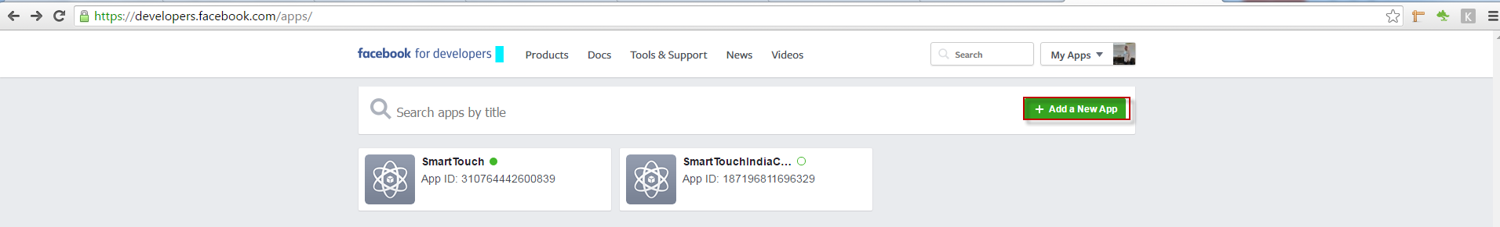

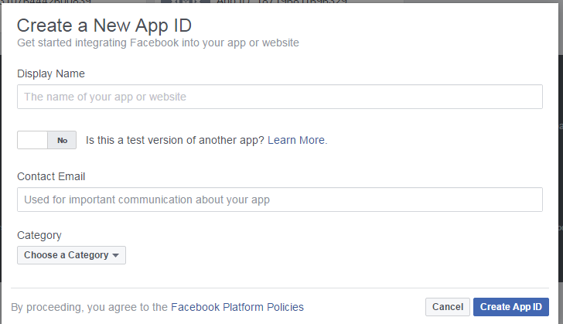

1. Enter the basic information out of which the Site URL is mandatory under ‘Settings’.
2. Click ‘Add Platform’; select the ‘Website’ option and enter your CRM URL and click on ‘Save Changes’.

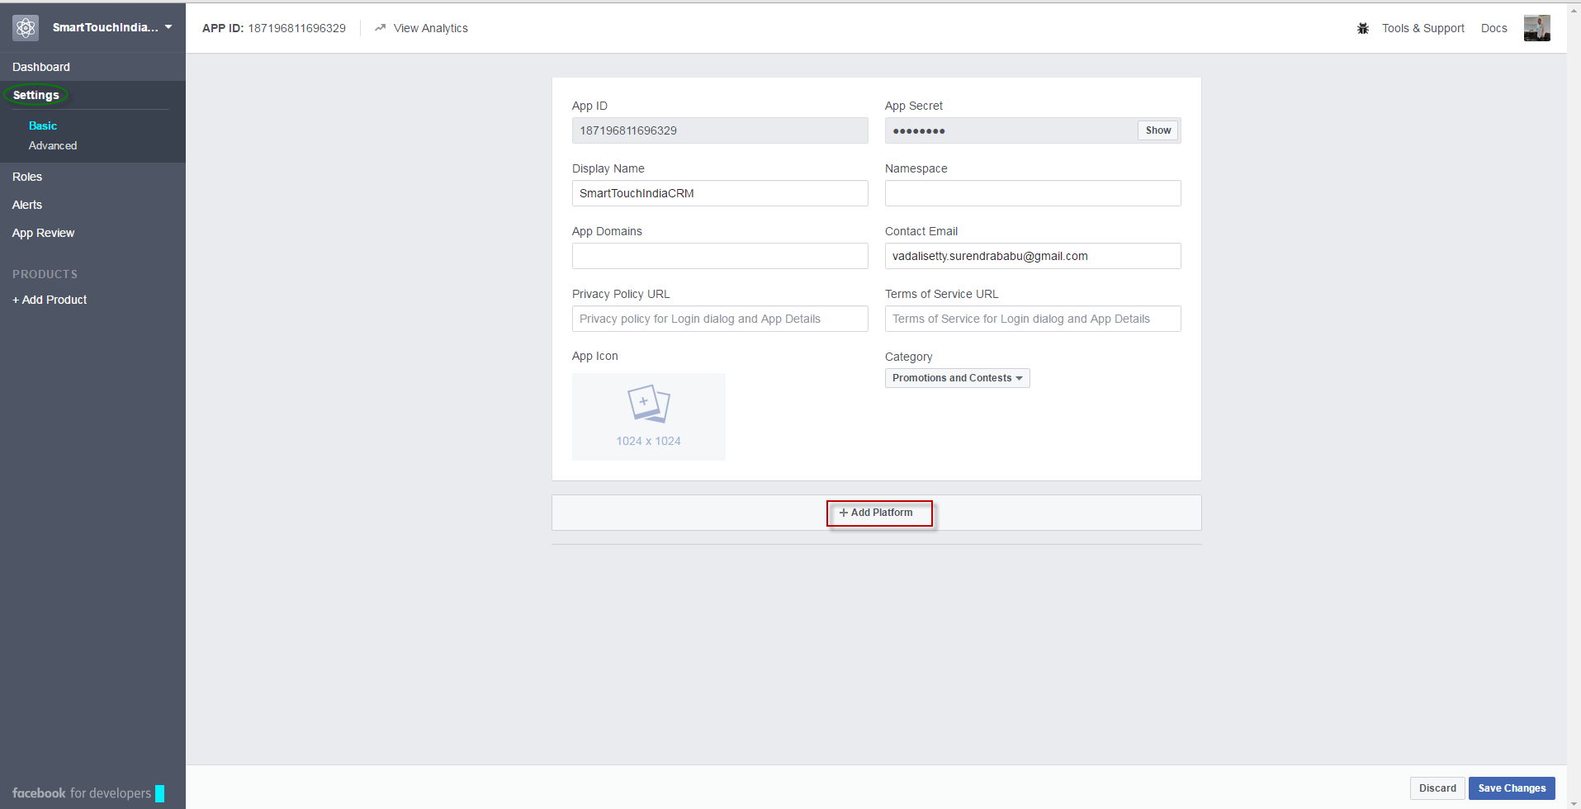

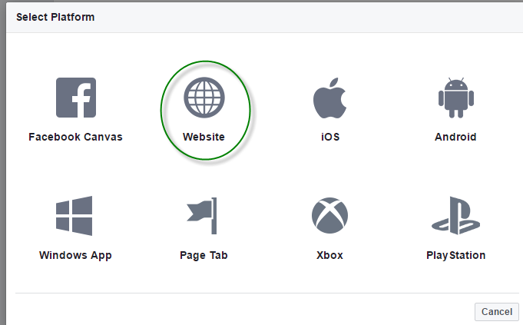

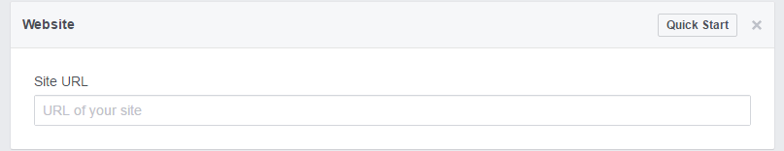

1. Under ‘App Review’ section, proceed with the basic settings that are observed.

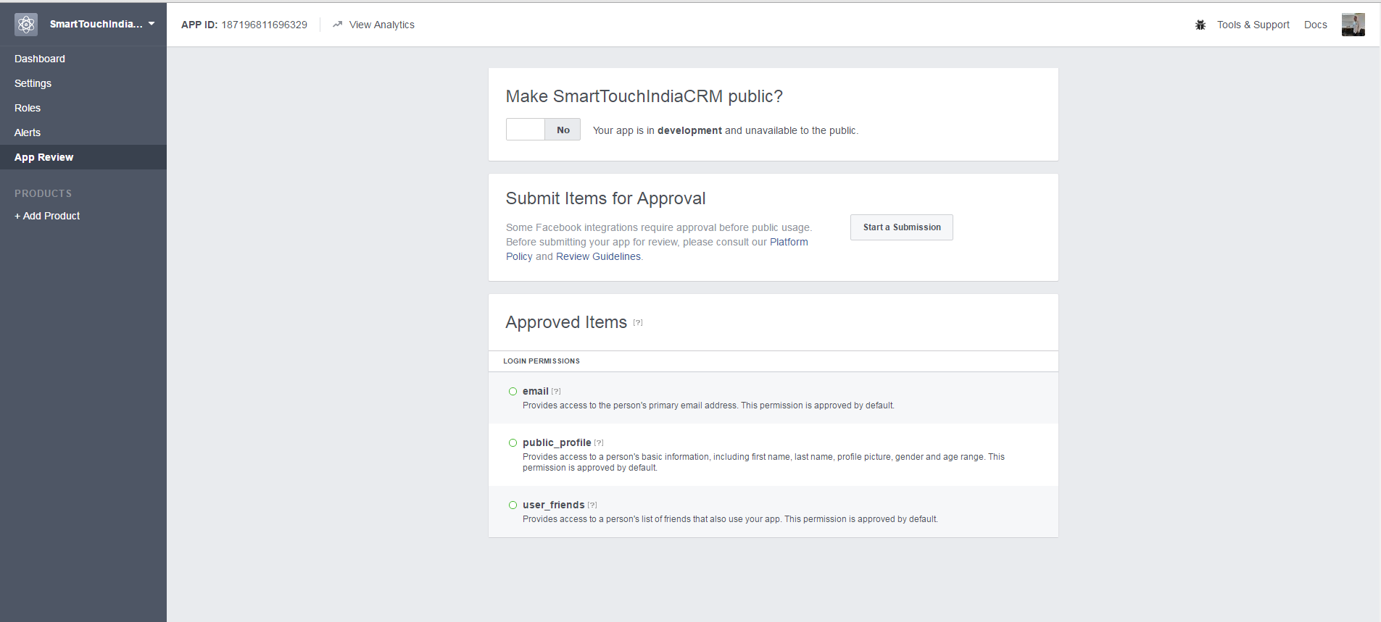

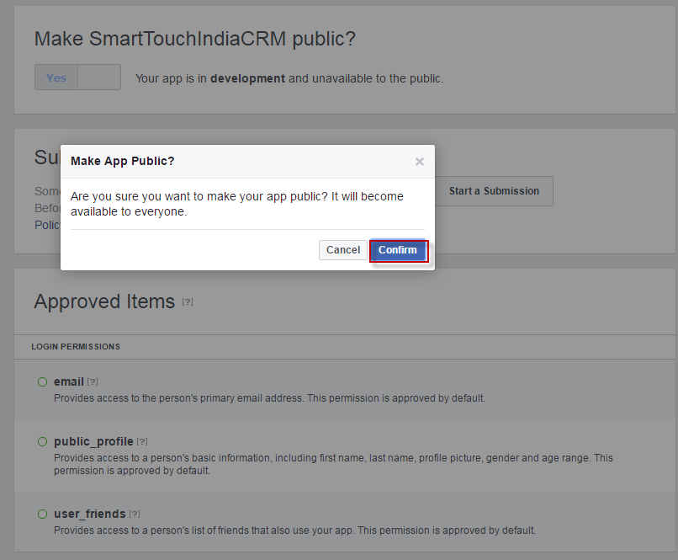

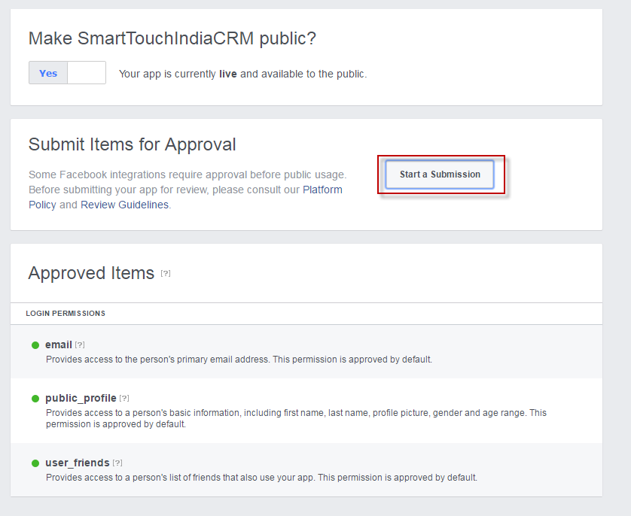

1. However one will have to request for ‘publish_actions’, under ‘Items in Review’ tab in order to post information.

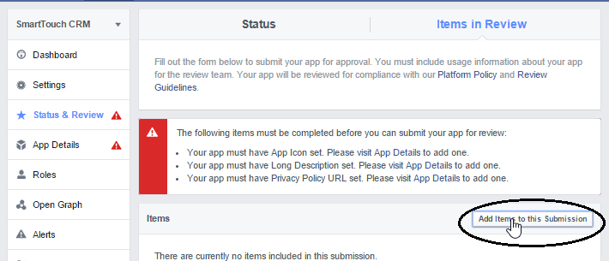

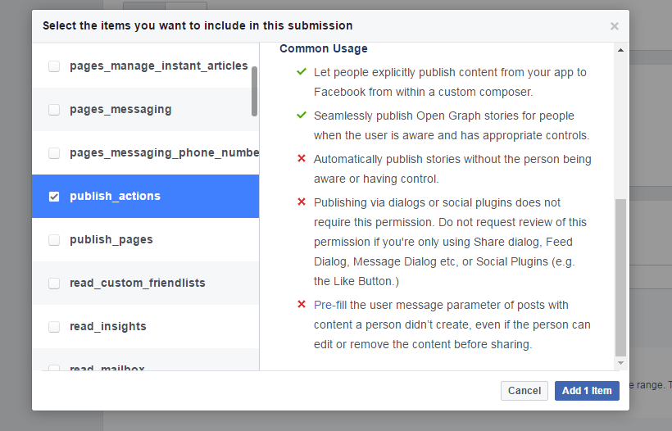

1. Post filling the necessary information, ensure the flag is set to ‘Yes’ which means that the ‘App’ is live.

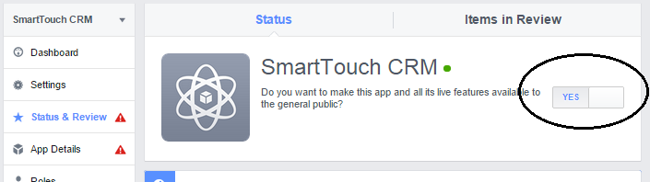

1. Enter additional information in Edit Notes section of permissions and submit for review.

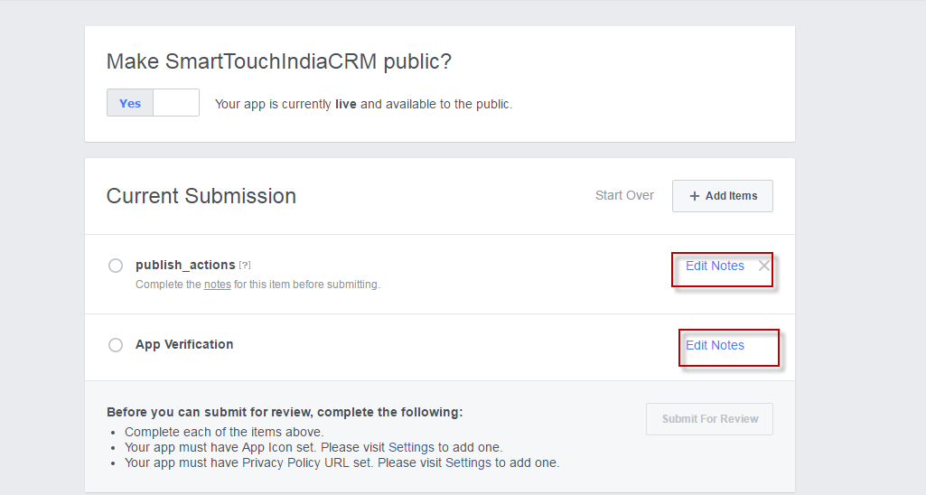

**Twitter**

1. Logon to “apps.twitter.com” and click on ‘Create New App”.

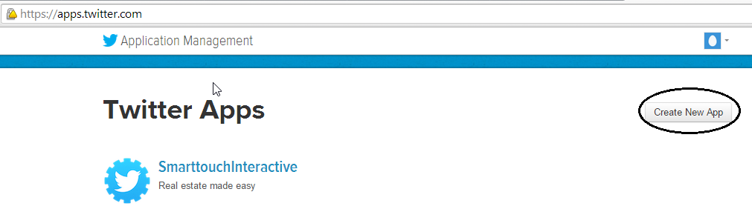

1. Enter the necessary information and click on ‘Create your Twitter application’ in order to get started.

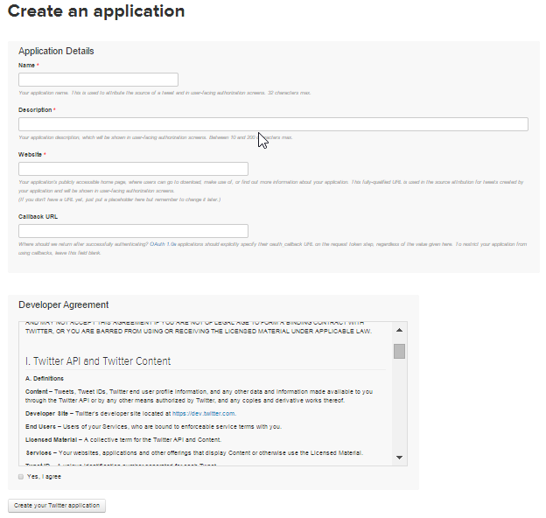

**Note:** The API configuration can be updated in the Account Settings window.